**PROJECT DESIGN PHASE 1**

**Proposed solution template**

|  |  |
| --- | --- |
| Date | 15 October 2022 |
| Team id | PNT2022TMID36938 |
| Project | Smart fashion recommender application |
| Maximum mark | 2 mark |

PROPOSED SOLUTION:

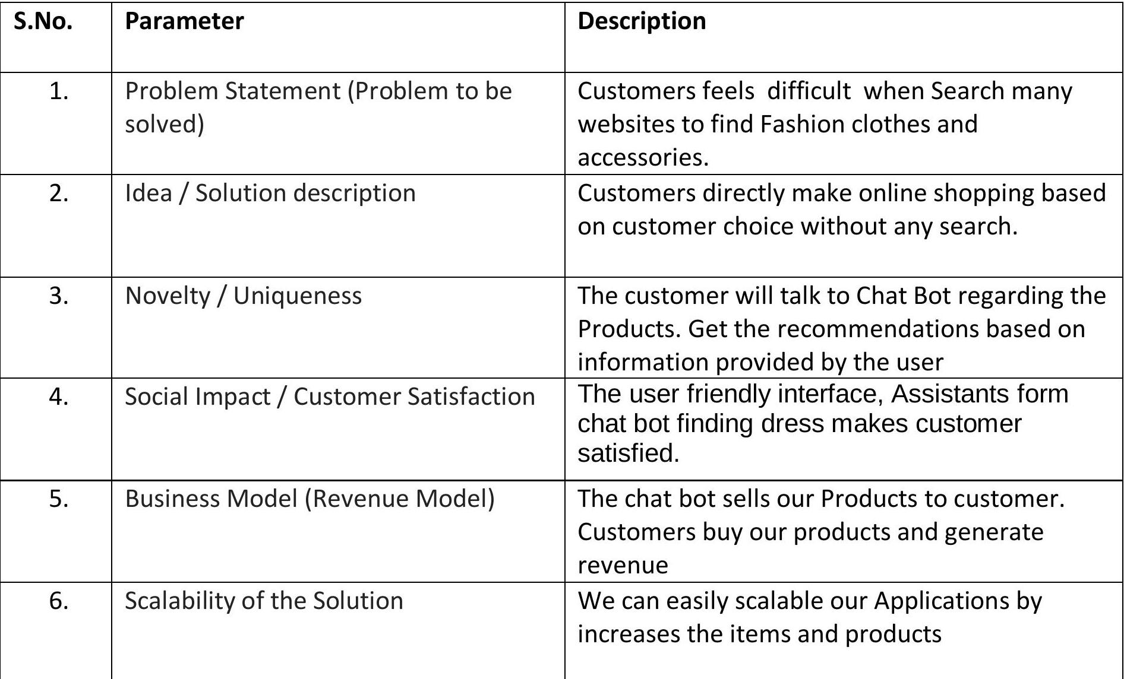

**SUBMITTED BY**

AAISHA – TEAM LEADER

**TEAM MEMBERS:**

HEMALATHA .S

KAVIYA.D

HARINI.R.P

SAVITHA.S